1. **How to create a custom repository in Spring Data JPA?**

Ans:

We can create custom repository extending any of these interfaces. Each one have special methods.

Repository  
CrudRepository  
PagingAndSortingRepository  
JpaRepository  
QueryByExampleExecutor

I) Create a custom repository extending Repository interface. The Repository interface is a marker interface. It doesn’t have any predefined methods.

Syntax:

Public interface StudentRepository extends Repository<Student,Serializable>{

}

II) Create a custom repository extending CrudRepository interface. The CrudRepository interface contains methods to perform CRUD operation. We get benefit to use those methods if we define our repository extending CrudRepository interface.

Syntax:

Public interface StudentRepostory extends CRUDRepository<Student, Serializable >{

}

1. **Write JPQL using @Query annotation in Spring Data JPA.**

Ans: In order to define SQL to execute for a Spring Data repository method, we can **annotate the method with the @Query annotation — its value attribute contains the JPQL or SQL to execute.**

**Syntax:**

@Query("SELECT k FROM User k WHERE k.status = 1")

Collection<User> findAllActiveUser**s**();

1. **Difference between Repository and** **CrudRepository in Spring Data JPA?**

|  |  |
| --- | --- |
| **Repository Interface (Marker Interface)** | **CrudRepository Interface** |
| The Repository is a top-level interface in hierarchy. | The CrudRepository extends Repository interface |
| The Repository is a marker interface. It doesn’t have any method. | It has below methods to perform CRUD operation.  Save(),saveAll(),findById(),etc.. |
| Repository interface has been defined as below:  @indexed  Public interface Repository<T,ID>{} | CrudRepository inface has been defined as below:  public interface CrudRepository<T, ID> extends Repository<T, ID> {  <S extends T> S save(S entity);…..  } |

Repository hierarchy:

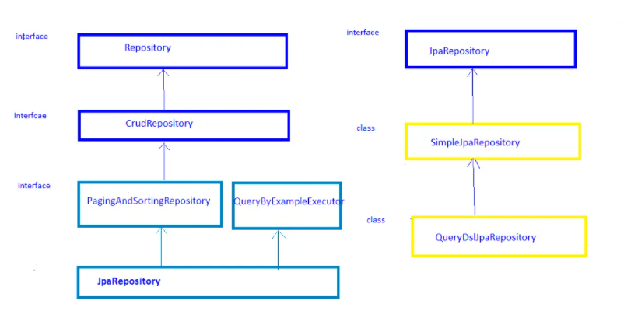

**4. Implement Spring MVC Project on Library management**

Create table ->Book(book_id(pk),book_name,publisher,published_date,pages)

Insert Book(s)

Get Book(s)

Update Book(s)

Ans: LibraryManagementSystem.zip attached.